**Section-End Project - Lesson 1**

**Spring Basics I**

### Assignment 01

A Model class “Movie” has the below properties

• movieId – String – E.g.: M001

• movieName – String – E.g.: The Firm

• movieActor – String – E.g.: Tom Cruise

• Create a spring xml configuration file to create a bean entry

for the Movie object with some sample property values

The client program should be able to display all the details of

the Movie object on the console.

Instructions:

1. Create a simple maven project.
2. Replace with the given pom.xml.
3. Edit the pom.xml using properties element or <build><plugins> element so as to have the IDE pick up the correct installed JDK version.(JDK 11). must be showing by default.
4. Add a display method to the Student class as below:

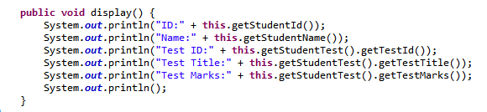

1. Create the model Movie class with appropriate getters and setters.
2. Create a class Main.java and add the following to the main method:

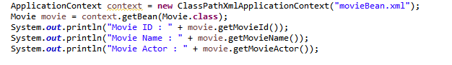

1. Run the application. Output should be as below:



